Data Representation: Data Storage
im_data_representation.php — Information Management

How computers store and work with data
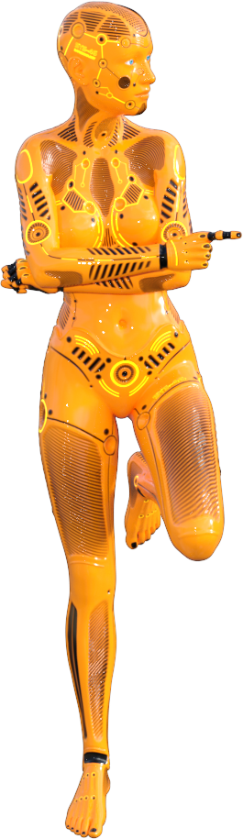

Explaining how the magic works
Computers seem magical. They can work with numbers, words, pictures, sound, movies, music, animation - and so much more.
How does one device know the difference between all these different types of data?
How does a device know the ways to store the different types of data?
And what is all this stuff about 'ones' and 'zeroes', bits, bytes, gigabytes, etc? It all sounds a bit gobbledy-gook to me!
This module is VIT (Very Important Theory). If you understand its contents you will have a much clearer idea of how computers work - and this will help make you a better programmer.
Make sure you complete the step by step tutorial below BEFORE you go to the other sections in this Chapter that explain things such as binary, hexadecimal, ascii, unicode, etc. in more detail.

What does data look like to a computer?
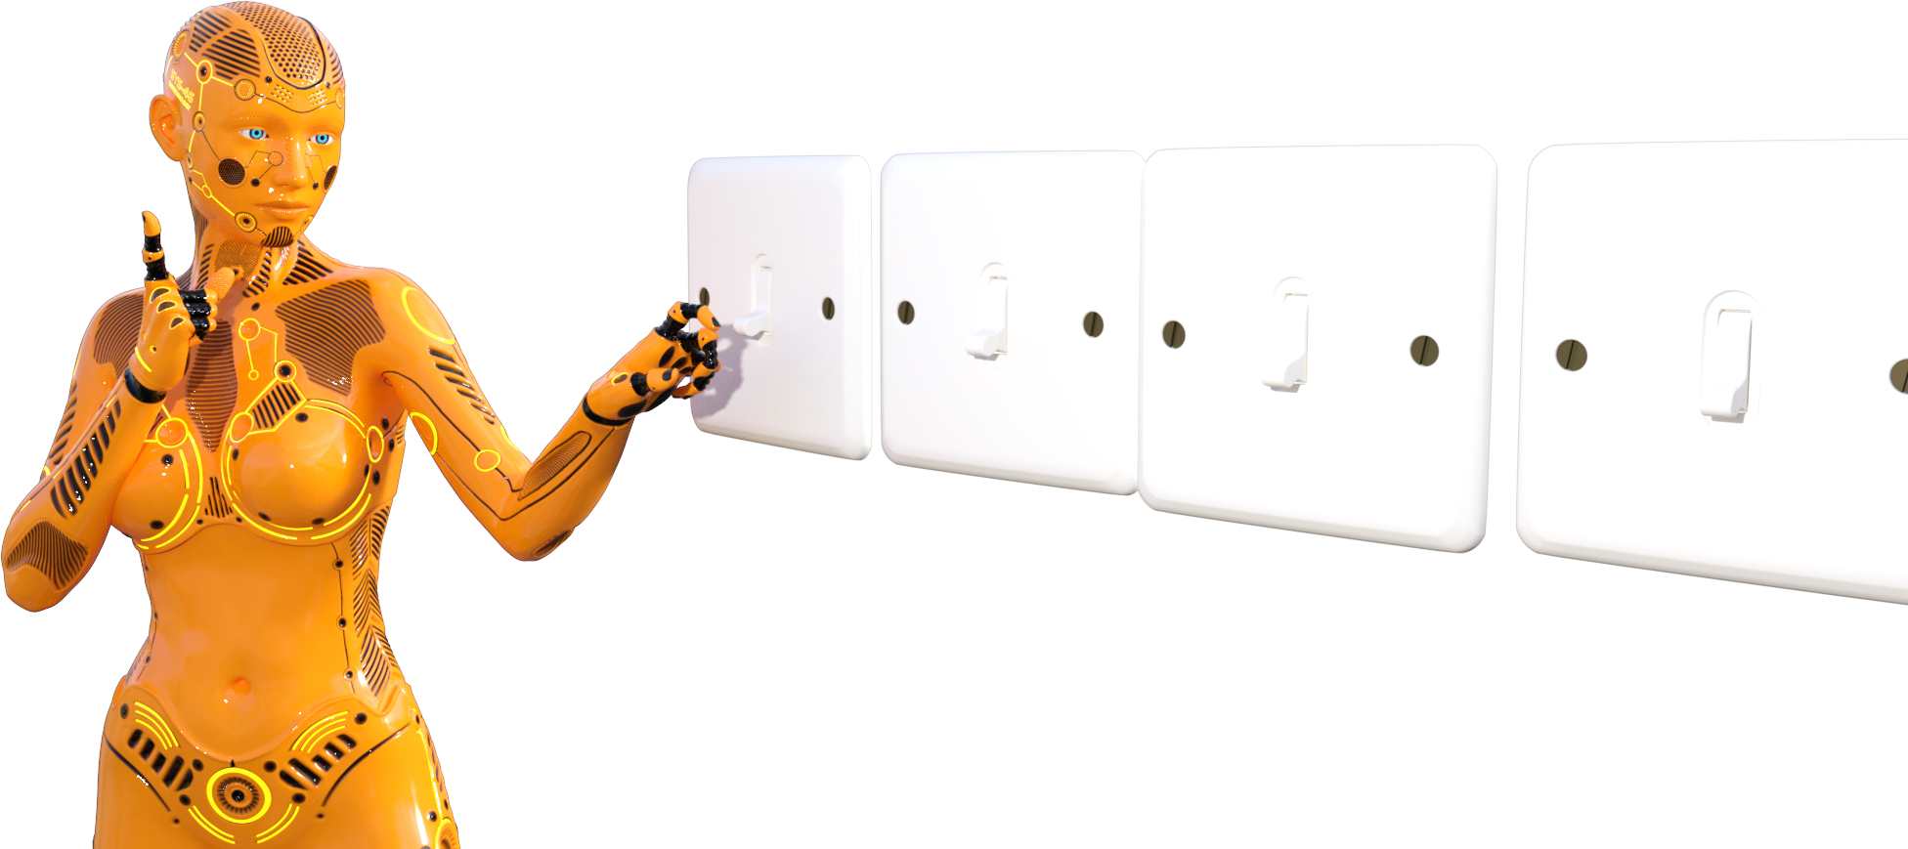
The simple answer to this question is….

Like a sequence of switches….
Just knowing that a computer sees and stores everything as a series of switches (yes, numbers, pictures, letters, colours, movies, sound - it is all just a series of switches) is one thing.
Don't you think it would be useful to understand how we get from the switches to something that we humans can actually recognise (i.e. turn switches back into numbers, pictures, letters, colours, , video or sound)?
The step - by - step tutorial below will show you just how that happens…
That's it!
You should now understand that computers store data as the positions of a series of switches - and that by using Binary we can treat this as numbers.We use codes to let the numbers represent anything from letters to sound and even colours.
Explaining how a computer 'sees' data - step by step…

This step-by-step tutorial works best if you hide the navigation menu by clicking its toggle icon at the top left of the tutorial.
If you need to find a specific step, you can always click the toggle again and the navigation menu will re-appear!
Hidden the navigator?
Good, then let's get started…. Click the 'Next' button below…
Memory is nothing but switches.
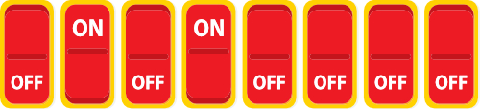

That is what a section of computer memory may look like.
8 switches.
Each switch can have two positions - it can be either ON or OFF.
Inside the computer these switches are really microscopic transistors or capacitors. Their value is not read as On or OFF but rather as a high voltage or a low voltage.
Writing out what is stored in memory
So how do we write out the contents of this memory?
How about: "Off, On, Off, On, Off, Off, Off, Off"?
That feels really tedious to write (trust me, I just typed it out). It's also difficult to read and even harder to say out loud and understand.
There has to be a better way!
Trading 'OFF, ON' for '0, 1'
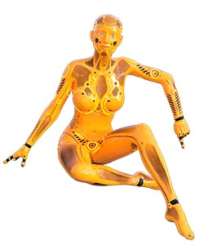
Lets think about this logically…..
Each switch has only two possible values, namely OFF and ON.
How about we represent each switch with a number to show the state of the switch - say a 0 for Off and a 1 for On?
This should work pretty well.
You can see the result below…
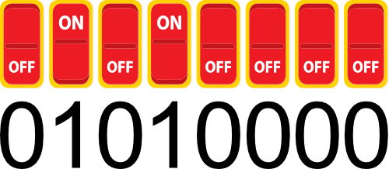
Can this be a number?
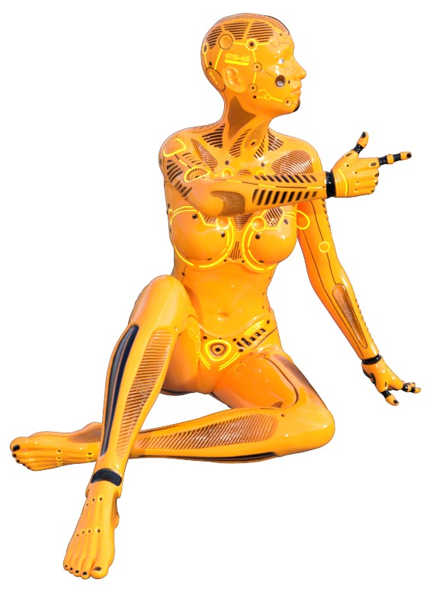
So we have

01010000
That seems a lot easier to write, to read and to say. It's also a bit easier to visualise and remember than a bunch of 'OFF. ON' statements.
It also has another advantage.
It looks like something we know very well - a number!
Can we use numbers to represent what is stored in memory? That would be soooo cool & convenient!
Detour - Meet BINARY
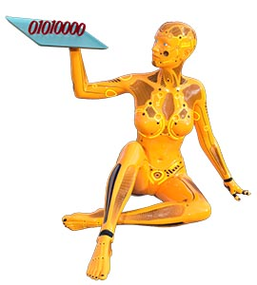
So yes,

01010000 is a number.
BUT it is not 1 million, ten thousand.
In fact, it is not a decimal number at all.
This number is in a number system which you may have already met (it's OK if you haven't).
The number system is called BINARY and we're going to take a short detour to understand what binary is before we go on with checking out how computers see, store and work with data.
BINARY explained…

We humans have 10 fingers.
We can use them to count from 0 to 9 (yes, I know that most of us use them to count from 1 to 10, but that is because we are doing it wrong! - Bear with me…).
Because this number system has TEN digits we call it DECIMAL - from the latin word for ten.
The poor computer doesn't have fingers - it has a switch.
That switch has only got TWO digits to work with. This means that a number system based on the switch would also only have two digits in it.
We call that number system BINARY - from the latin word for two.
How counting works…
As already said, we humans have 10 fingers .
We know that we use them to count from 0 to 9 .
When we get to 9 we run out of fingers, make a note of how many times we have run out of fingers and then start again at 0 .
We repeat this process until the number of times we have run out of fingers is 9.
When we run out of fingers again we reset that counter to 0 and start a new count for how many times that counter has got past 9.

How to understand a written out Decimal number
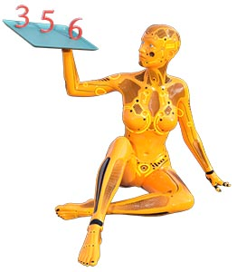
The result is a number system where we start from the right hand side with the smallest values and keep on adding digits to the left hand side with higher values.
The cool thing about writing numbers down this way is that we can easily tell how big a number is just by how many digits it is from the right.
Take 3 5 6 for example.
The 6 is zero digits from the right. It IS the right.
If we take the number the whole system is based on (i.e. 10) and raise it to the power of the distance the digit is from the right (in this case 0) then we get the true value of the number in that column.
10 ^ 0 = 1 (NB: any number ^ 0 = 1).
Now take 6 and multiply it by that column size (i.e. 6 x 1) and you get the true value of the number (in this case it is 6)
How to understand a written out Decimal number
Lets do the same for the 5 in 3 5 6.
5 is ONE digit from the right. This means that its base size is 10 ^ 1 = 10 .
The end result (i.e. 5 x 10) shows us that the 5 actually represents 50.
Finally we can do the same for the 3 in 3 5 6 . Work it out for yourself before clicking to reveal the answer…
3 is TWO digits from the right.
10 ^ 2 = 100 .
3 x 100 = 300 .
Add them all together (6 + 50 + 300) and we have the value three hundred and fifty six.
This method works for writing out ALL decimal numbers.
It is also how writing any number in any number system works.
How to understand a written out Binary number
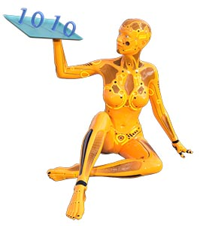
In Binary, just like decimal, we start from theright hand side with the smallest values and keep on adding digits to the left hand side with higher values.
The big difference is that instead of TEN possible values in each column (0 - 9) in Binary we only have TWO possible values (0 and 1)
Take 1010 for example.
The first 0 is zero digits from the right. It IS the right.
if we take the number the whole system is based on (i.e.2) and raise it to the power of the distance the digit is from the left (in this case 0) then we get the true value of the number in that column.
2 ^ 0 = 1 (NB: any number ^ 0 = 1).
Now take 0 and multiply it by that column value (i.e. 0 x 1) and you get the true value of the number.
How to understand a written out Binary number
Lets do the same for the next digit (i.e. 1) in 1010.
This 1 is ONE digit from the right. This means that its base size is 2 ^ 1 = 2 . The end result (i.e. 1 x 2) shows us that the 1 actually represents 2.
The end result looks like this:
1 0 1 0: 1 x 2 ^ 0 = 0 x 1 = 0
1 0 1 0: 1 x 2 ^ 1 = 1 x 2 = 2
1 0 1 0: 0 x 2 ^ 2 = 0 x 4 = 0
1 0 1 0: 1 x 2 ^ 3 = 1 x 8 = 8
We add these numbers together and we have the decimal value of the binary number!
0 + 2 + 0 + 8 = 10
End of detour: Codes and Symbols
Let's go back to the value we got from our 8 switches of memory…

01010000
It turns out that this value is the binary representation of a number.
We humans are good at thinking and working with numbers, symbols and codes.
After all, we use them all the time (language is a set of written or spoken codes that represent things and actions in the world; maths is a set of codes and rules for measuring and explaining things precisely).
Suddenly we have gone from a bunch of difficult to remember switches to a number. Take a moment to think how significant and meaningful this is!
We can use a number for maths and calculations.
We can use a number to represent things (i.e. like a code or symbol).
Treating this as a number means that we actually have power - and can do things!
What 01010000 means…
You can convert 01010000 into decimal using the method described when talking about Binary earlier (if you forget how open the menu on the side and go back to that slide).
Try it for yourself before revealing the answer below…
01010000 =
0 x 2 ^ 0 = 0 x 1 = 0
0 x 2 ^ 1 = 0 x 2 = 0
0 x 2 ^ 2 = 0 x 4 = 0
0 x 2 ^ 3 = 0 x 8 = 0
1 x 2 ^ 4 = 1 x 16 = 16
0 x 2 ^ 5 = 0 x 32 = 0
1 x 2 ^ 6 = 1 x 64 = 64
0 x 2 ^ 7 = 0 x 128 = 0
= 0 + 0 + 0 + 0 + 16 + 0 + 64 + 0 = 80
Codes give numbers extra meanings
The meaning of 80 can just be a number.
We have already seen that it can be represented as 01010000 in Binary.
Another important numbering system used by programmers is Hexadecimal and 80 in Hexadecimal is (Hex is discussed below in the section on Number Systems - you can look there to try to figure put what 80 is in hex before showing the answer)…. 80 is actually 50 in Hexadecimal .
In this course 80 is the pass mark for the tests you take.
The number 80 can also be used to represent many other things:
In a computer, colours are actually numbers. This text is in the colour represented by the number 80.
Because computers only work with numbers, people had to work out a way for the computer to store and work with letters that really uses numbers.
To do this we created tables where each letter of the alphabet was linked to a specific number. One of the first examples of this type of encoding was called the ASCII table.
In the ASCII table (discussed below in the section on Data Representation - you can look it up if you like before revealing the answer…) 80 represents the letter 'P' .
Codes give numbers extra meanings
80 can be the frequency of a sound that must be played, or the colour of a pixel in a photo or movie.
80 can be the length of a line drawn in a vector graphic - or the angle of a line drawn in a CAD program.
Most importantly, 80 could also be an instruction to the CPU or anaddress (in memory or of a hardware device).

To Sum UP…
Ultimately in a computer people work out ways to encode everything into numbers.
Those numbers are converted into binary.
They are stored in the computers memory as a series of switches that are either on or off - letting either a low or high voltage get transmitted.

Video Links - Number Systems (Binary, Hexadecimal, Octal)
We have selected and curated a set of videos on YouTube related to your course.
These videos are not created or owned by us.
They may display advertising and in some cases may contain limited amounts of swearing.

Notes for this Module
What to look out for and do in this module...

FAQs for this module
Questions on Data Representation - and their answers...

Network Types FAQ
View the questions or type in the term you are looking for below…
No results were found

What is computer memory?
It is a series of switches that can be either on or off.
If we use the on / off positions of these switches as binary numbers and group them together (e.g. 8 switches grouped together = a Byte) then you have a way to represent numbers in memory.
Numbers can be arranged into codes and used to represent other things - from a letter / character to a colour value.
So, Computer Memory is a series of switches that we arrange and use rules for so that they can represent any type of data.

What is a Bit?
A Binary Digit - a single switch that can be on or off / 0 or 1.

Is a bit in memory really a switch?
It depends.
Most of the time a bit is a combination of a capacitor (like a mini battery) combined with circuits that can read whether the capacitor holds a charge or not.
In the type of memory used for electronic storage, the answer is yes - but it is a group of switches arranged into a circuit called a 'flip-flop'.

Why did the Byte become the standard 'chunk' of memory for holding data?
Because it gave a range of numbers (0 - 255) that could be used to create a table which could represent characters and instruction codes.

